Roll No-12

M.sc. 3rd semester

Date of Assignment-21/12/2020

Date of Submission-12/01/2021

**Experiment No -12**

**Topic**- Fitting of auto regressive (AR) series to time series data.

**Problem** – Fit an auto regressive series of the form-



to the following data and then find the period of the fitted AR(2). Also fit an AR(3) considering the same data.

|  |  |
| --- | --- |
| **t** | **ut** |
| 1 | 5.5933 |
| 2 | -2.4558 |
| 3 | -7.4251 |
| 4 | -4.0501 |
| 5 | 5.1414 |
| 6 | 5.614 |
| 7 | -0.0622 |
| 8 | 0.7227 |
| 9 | 0.7997 |
| 10 | 2.6251 |
| 11 | -2.1324 |
| 12 | -0.854 |
| 13 | -0.7279 |
| 14 | 2.0284 |
| 15 | 7.967 |
| 16 | 6.1003 |
| 17 | -1.0224 |
| 18 | -2.5796 |
| 19 | -2.7597 |
| 20 | -5.755 |
| 21 | -0.5003 |
| 22 | 3.533 |
| 23 | 2.6143 |
| 24 | 0.7917 |

**Theory and Calculation**-

**Part-A-** Fitting of AR(2)

The auto-regressive series of order k is given by-

 where 

Now, taking the deviation of the observations  from their mean  and replacing the  with these deviations, the series becomes-



When k=2, the AR series of order k reduces to-

 ----(1)

Multiplying (1) by , we get-

 ----(2)

Taking expectation on both sides of equation (2), we get-



 ----(3)

where Ck represents the auto-covariance function at lag k.

Dividing both sides by , we get from (3)

 ----(4)

where  represents the auto-correlation at lag k.

In practice,  is determined by the sample counter-part of  i.e. . Putting k=1 and k=2 in equation (4), we get-

  & 



Replacing  &  by  &  respectively, we get-







 ----(5)

Solving (5), we get the estimate of the coefficients . Therefore, the fitted AR series of order 2 is-



The period of the fitted second order AR series is given by-

, where 

Finally, we have 



**Calculation-**

we construct the following table-

|  |  |
| --- | --- |
| **t** | **Est_ut** |
|  |  |
| **1** | **0** |
| **2** | **0** |
| **3** | **-3.99353** |
| **4** | **-2.50595** |
| **5** | **2.239708** |
| **6** | **5.838234** |
| **7** | **1.0494** |
| **8** | **-2.58308** |
| **9** | **1.013877** |
| **10** | **0.626706** |
| **11** | **1.668575** |
| **12** | **-2.16431** |
| **13** | **1.219092** |
| **14** | **0.588897** |
| **15** | **2.156666** |
| **16** | **4.164123** |
| **17** | **-0.22018** |
| **18** | **-3.42169** |
| **19** | **-0.41818** |
| **20** | **0.333706** |
| **21** | **-1.34625** |
| **22** | **3.427244** |
| **23** | **2.924907** |
| **24** | **0.154608** |

**Programming in R**

library(readxl)

df_1 = read_excel("Autocorrelation_2.xlsx")

View(df_1)

ut = c(5.5933,-2.4558,-7.4251,-4.0501,5.1414,5.614,-0.0622,0.7227,0.7997,2.6251,-2.1324,-0.854,-0.7279,2.0284,7.967,6.1003,-1.0224,-2.5796,-2.7597,-5.755,-0.5003,3.533,2.6143,0.7917)

ut

N = length(ut)

N

ut_bar = mean(ut)

ut_bar

c0 = sum((ut-ut_bar)^2)/N

c1 = (sum((ut[1:23]-ut_bar)*(ut[2:24]-ut_bar)))/N

c2 = (sum((ut[1:22]-ut_bar)*(ut[3:24]-ut_bar)))/N

r1 = c1/c0

r2 = c2/c0

A = array(c(r1,r2),dim=c(2,1))

B = array(c(1,r1,r1,1),dim=c(2,2))

coeff = solve(B)%*%A

coeff

theta = acos(coeff[1,1]/(2*sqrt(abs(coeff[2,1]))))

period = (2*pi)/theta

period

f_term = coeff[1,1]*ut[2:23]

s_term = coeff[2,1]*ut[1:22]

utp_est = f_term+s_term

ut_est = utp_est+ut_bar

ut_est

df_a = append(0,ut_est)

df_2 = append(0,df_a)

View(df_2)

Data = cbind(df_1,df_2)

Data

#using ggplot to plot the graph

library(ggplot2)

ggp = ggplot(NULL, mapping = aes(t)) +

geom_point(data = Data, mapping = aes(y=ut), col = "black") + geom_line(data = Data, mapping = aes(y=ut), col = "orange", size = 1) +

geom_point(data = Data, mapping = aes(y=df_2), col = "blue") + geom_line(data = Data, mapping = aes(y=df_2), col = "green", size = 1) +

labs(

title = paste("Plotting of observed ut and estimated ut against t"),

subtitle = paste("orange_line=observed ut and green_line=estimated ut"),

caption = "Data from Model",

x = "t",

y = "observed_ut_and_estimated_ut"

)

ggp

**Graph plotting**

We plot the graph of observed and estimated values for the second order series considering t along X-axis and  &  along Y-axis by Using ggplot2-

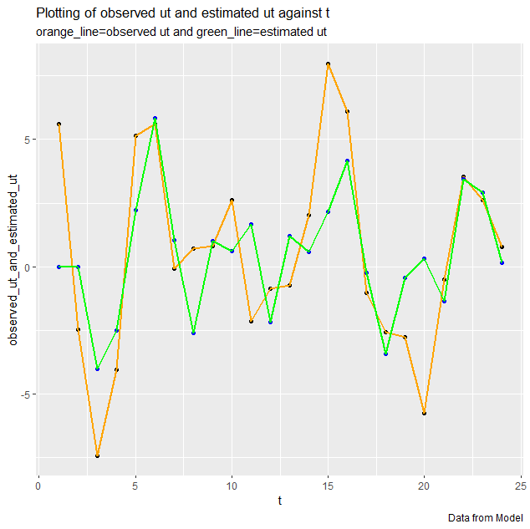

**Tableau-**

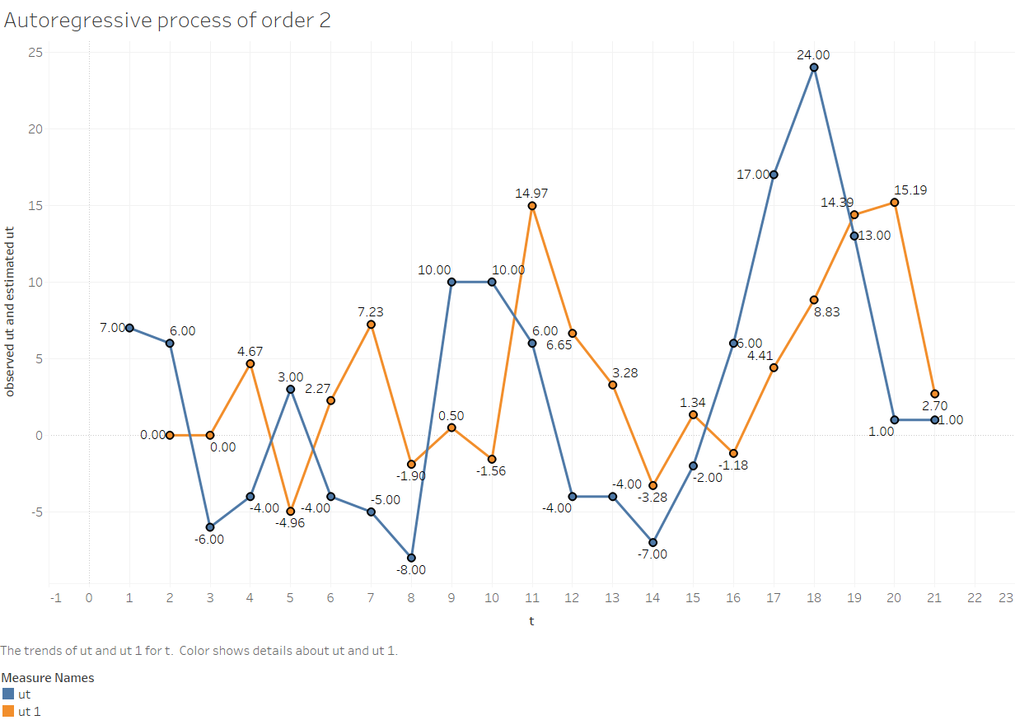

**Conclusion-**

The fitted AR(2) is-



The period of the fitted AR series of order 2 is 5.41955.

**Part-B-**Fitting of AR(3)

The auto-regressive series of order k is given by-

 where 

Now, taking the deviation of the observations  from their mean  and replacing the  with these deviations, the series becomes-



when k=3, the AR series reduces to-

 ----(1)

Multiplying both sides of (1) by  and taking expectation, we get-



 ----(2)

Dividing both sides of equation (2) by , we get-

 ----(3)

In practice,  is determined by the sample counter-part of  i.e. . Putting k=1,k=2 and k=3 in equation (3), we get-

  & 





Replacing  &  by  &  respectively, we get-









 ----(4)

Solving (4), we get the estimate of the coefficients . Therefore, the fitted AR series of order 3 is-



Finally, we have 



**Calculation-**

we construct the following table-

|  |  |
| --- | --- |
| **t** | **Est_ut** |
|  |  |
| **1** | **0** |
| **2** | **0** |
| **3** | **0** |
| **4** | **-2.68617** |
| **5** | **2.256708** |
| **6** | **5.971319** |
| **7** | **1.293682** |
| **8** | **-2.6911** |
| **9** | **0.645151** |
| **10** | **0.629779** |
| **11** | **1.56523** |
| **12** | **-2.04632** |
| **13** | **1.010592** |
| **14** | **0.712419** |
| **15** | **2.114174** |
| **16** | **4.014099** |
| **17** | **-0.26044** |
| **18** | **-3.65204** |
| **19** | **-0.7403** |
| **20** | **0.395398** |
| **21** | **-1.09547** |
| **22** | **3.403901** |
| **23** | **3.138796** |
| **24** | **0.225133** |

**Programming in R**

library(readxl)

df_1 = read_excel("Autocorrelation_2.xlsx")

View(df_1)

ut = c(5.5933,-2.4558,-7.4251,-4.0501,5.1414,5.614,-0.0622,0.7227,0.7997,2.6251,-2.1324,-0.854,-0.7279,2.0284,7.967,6.1003,-1.0224,-2.5796,-2.7597,-5.755,-0.5003,3.533,2.6143,0.7917)

ut

N = length(ut)

N

ut_bar = mean(ut)

ut_bar

c0=sum((ut-ut_bar)^2)/N

c1=(sum((ut[1:23]-ut_bar)*(ut[2:24]-ut_bar)))/N

c2=(sum((ut[1:22]-ut_bar)*(ut[3:24]-ut_bar)))/N

c3=(sum((ut[1:21]-ut_bar)*(ut[4:24]-ut_bar)))/N

r1=c1/c0

r2=c2/c0

r3=c3/c0

A=array(c(r1,r2,r3),dim=c(3,1))

B=array(c(1,r1,r2,r1,1,r1,r2,r1,1),dim=c(3,3))

coeff=solve(B)%*%A

coeff

f_term=coeff[1,1]*ut[3:23]

s_term=coeff[2,1]*ut[2:22]

t_term=coeff[3,1]*ut[1:21]

utp_est=f_term+s_term+t_term

ut_est=utp_est+ut_bar

ut_est

df_a = append(0,ut_est)

df_b = append(0,df_a)

df_2 = append(0,df_b)

View(df_2)

Data = cbind(df_1,df_2)

Data

#using ggplot to plot the graph

library(ggplot2)

ggp = ggplot(NULL, mapping = aes(t)) +

geom_point(data = Data, mapping = aes(y=ut), col = "black") + geom_line(data = Data, mapping = aes(y=ut), col = "orange", size = 1) +

geom_point(data = Data, mapping = aes(y=df_2), col = "blue") + geom_line(data = Data, mapping = aes(y=df_2), col = "green", size = 1) +

labs(

title = paste("Plotting of observed ut and estimated ut against t"),

subtitle = paste("orange_line=observed ut and green_line=estimated ut"),

caption = "Data from Model",

x = "t",

y = "observed_ut_and_estimated_ut"

)

ggp

**Graph plotting**

We plot the graph of observed and estimated values for the third order series considering t along X-axis and  &  along Y-axis by using ggplot 2-

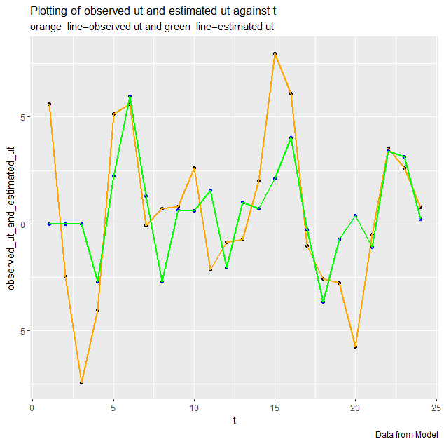

**Tableau-**

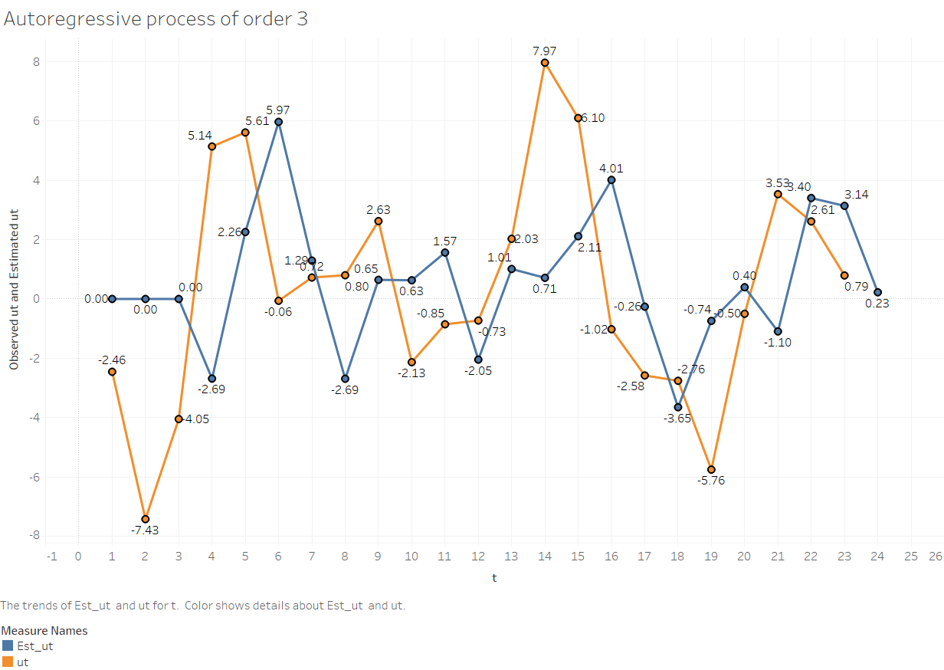

**Conclusion-**

The fitted AR(3) is-

